MEMT 201 HW #8

1. You have a 1080 steel.

a) For a 1080 steel that has been water quenched, estimate the tempering time at 425 deg. C (800 deg. F) to achieve a hardness of 50 HRC.
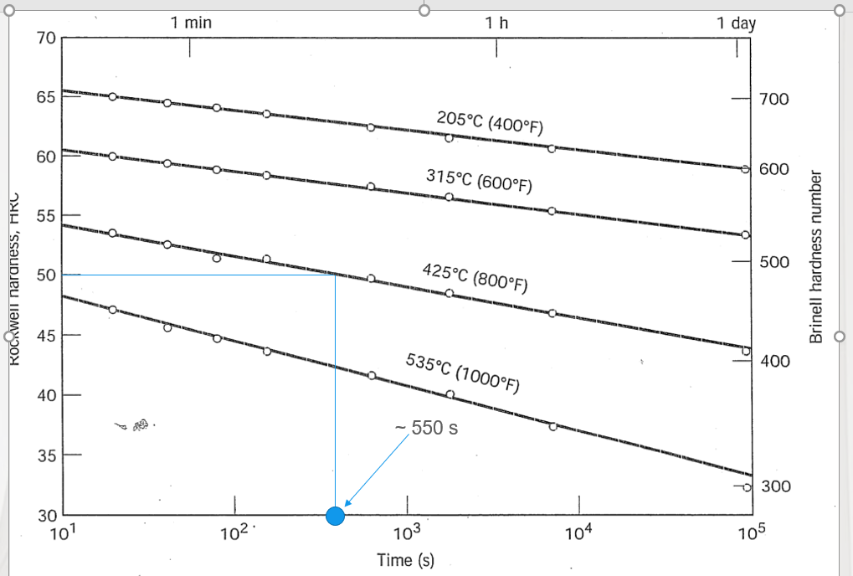
This is a screenshot of the chart in the steel processing powerpoint on moodle with the estmation lines drawn on.

b) What will be the tempering time at 315 Deg. C (600 Deg. F) necessary to attain the same hardness?

Extending the same chart long enough that a line stemming horizontally from the 50 HRC mark intersects with the 315° C line, the estimation seems to fall around 6.7*10⁶ s

2. Determine the range of compositions in a copper beryllium phase diagram that are suitable for age hardening?

The optimal range for age hardening of a Cu-Be alloy would be the range containing the edge between the α phase region and the hybrid regions at colder temperatures.

This phase diagram was retrieved from Bing images.
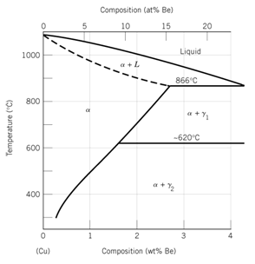
These two lines roughly mark the optimal region for age hardening.

These markers run roughly from about 0.2% Be to 2.7% Be.

3. You have a 2014 aluminum alloy that will need to exhibit a yield strength of 50 ksi and a ductility of 12% (% elongation). Specify a practical heat treatment to achieve these values.

The two following images are from the Non-ferrous Metals Processing powerpoint.
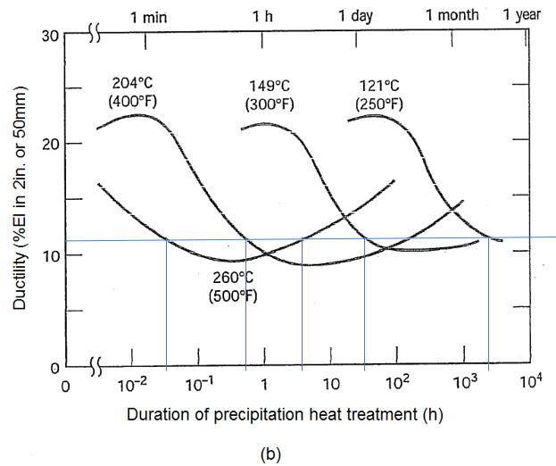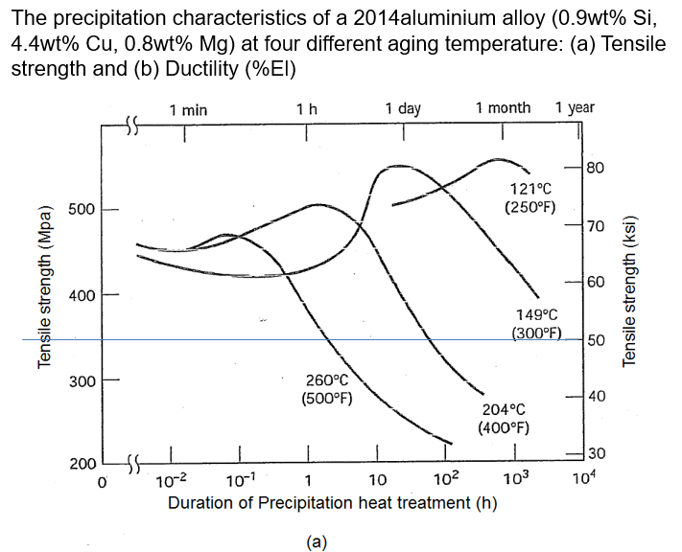

According to diagram (a), it is not possible to reach 50 ksi tensile strength when treating at 149° C or 121° C. When treating at 204° C, it would take close to 100 hours to reach the desired strength, which is somewhat longer than practical. Treating at 260° C reaches the desired strength in less than 10 hours. This is a practical amount of time.

When treating at 260° C, the desired 12% %E.L. is reached early in less than 0.1 hours, before our desired strength is reached. The desired %E.L. is reached a second time at this temperature at some time less than 10 hours, which matches our practical tensile strength treatment time. Therefore, the aluminum alloy should be treated at 260° C for 5-7 hours to achieve the desired properties.

